MODULE 1: Anatomy & Physiology (解剖与生理)
1. Eyeball Basics & Refraction (眼球基础与屈光)
Dimensions: Diameter 24mm, Weight 7g. Total refractive power: 55D - 60D.
Focus Power Distribution: Cornea provides ~3/4 (~45D) of focusing power. Lens provides ~1/4 (~15D).Refractive Errors Correction: Hyperopia (远视) uses Convex (凸透镜, 边缘薄中间厚); Myopia (近视) uses Concave (凹透镜, 边缘厚中间薄). Astigmatism (散光) uses Toric lenses (散光隐形眼镜).
- Accommodation & Aqueous Flow (调节与房水循环)
The lens fine-tunes the focus of light onto the retina by changing its shape, a process called accommodation.
·Near object → Ciliary muscle contracts (睫状肌收缩) → Zonules relax (悬韧带放松) → Lens becomes thicker/more curved (晶状体变凸，屈光力增加).
·Far object: Ciliary muscle relaxes → Zonules tighten → Lens flattens.
·Aqueous humour Flow房水循环: watery fluid in the anterior chamber; produced by Ciliary body (produces) → Pupil → Anterior Chamber前房 → Trabecular meshwork (小梁网, drainage).
·Increased eye pressure due to blood or inflammation in the anterior chamber can lead to Glaucoma青光眼
3. Vitreous, Retina & Protective Structures
·Vitreous玻璃体: 80% of eye volume, 99% water. Maintains shape.
·Retina视网膜: Fovea中央凹 (highest visual acuity, only Cones, inner layers pushed aside). Optic disc视神经 (Blind spot, no photoreceptors).
·Protective Structures: Orbit眼眶 (7 bones). Orbicularis眼神经 oculi (closes eyelid), Levator (opens eyelid). Bulbar conjunctiva (covers sclera), Palpebral conjunctiva (covers inner eyelid). Contact lens can NEVER get lost behind the eye; trapped in the fornix (穹窿).
三叉神经 (Trigeminal nerve) → 眼神经 (Ophthalmic nerve) → 额神经 (Frontal nerve) → 眶上神经 (Supraorbital nerve)
4. Ciliary Body, Iris & Lens Layers
·Ciliary body睫状体: Pars plicata睫状冠 (anterior, crown-shaped, produces aqueous). Pars plana (posterior, scalloped).
·Iris muscles虹膜肌肉: Sphincter 括约肌(circular, constricts pupil). Dilator开大肌 (radial, dilates pupil).
e.g. When you walk into a dark cinema, the iris dilates due to relaxation of the sphincter pupillae muscle and contraction of the dilator pupillae muscle.
·Iris blood supply: Long posterior ciliary & anterior ciliary arteries.
·Lens layers晶状体: Capsule囊膜 (outer) → Cortex皮质 (middle) → Nucleus核心 (center).
5. Extraocular Muscles & Cranial Nerves (眼外肌与脑神经)
Origin: All rectus muscles originate from Annulus of Zinn (总腱环). Superior oblique passes through the Trochlea (滑车).
CN III (Oculomotor): Rest of muscles, Levator, Pupil sphincter. 控制提上睑肌、瞳孔括约肌。受损特征 = 瞳孔散大 (Dilated pupil)
CN IV (Trochlear): 只控制Superior Oblique.
CN VI (Abducens): Lateral Rectus. Palsy = Horizontal diplopia (水平复视).
·Synergists (看向右上角):「 左眼 (Left eye)：需上转+内收。
收缩 (Synergists)：Superior rectus + Inferior oblique。
放松 (Antagonists)：Inferior rectus + Superior oblique。
「右眼 (Right eye)：需上转+外展。
收缩 (Synergists)：Inferior oblique + Superior rectus + Lateral rectus。
放松 (Antagonists)：Inferior rectus + Superior oblique + Medial rectus。
e.g. The contracting synergist muscles for the left eye are the superior rectus and the lateral rectus. The contracting synergist muscles for the right eye are the inferior oblique, the medial rectus and the superior rectus. The relaxing antagonist muscles for the left eye are the inferior rectus and the medial rectus. The relaxing antagonist muscles for the right eye are the superior oblique, the lateral rectus and the inferior rectus.
- The rectus muscles meet at a fibrous circular area that surrounds the optic nerve called the common tendinous ring
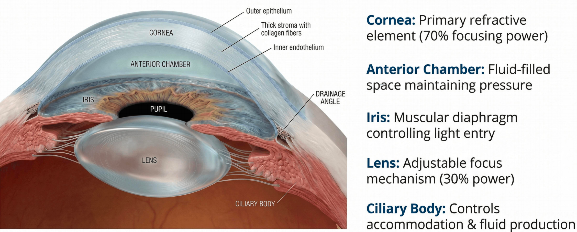
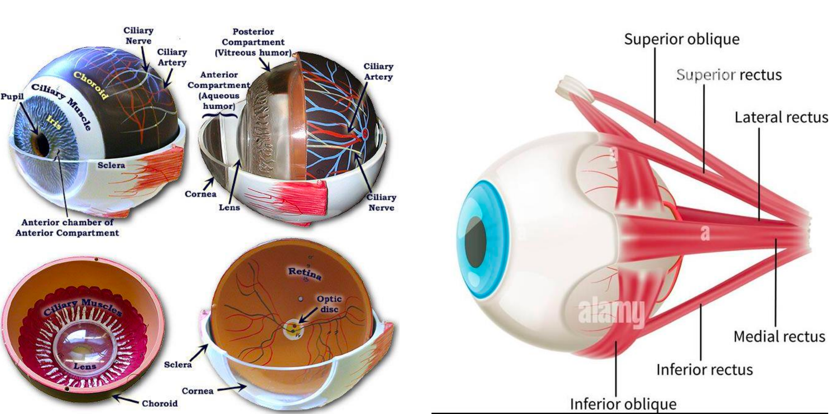
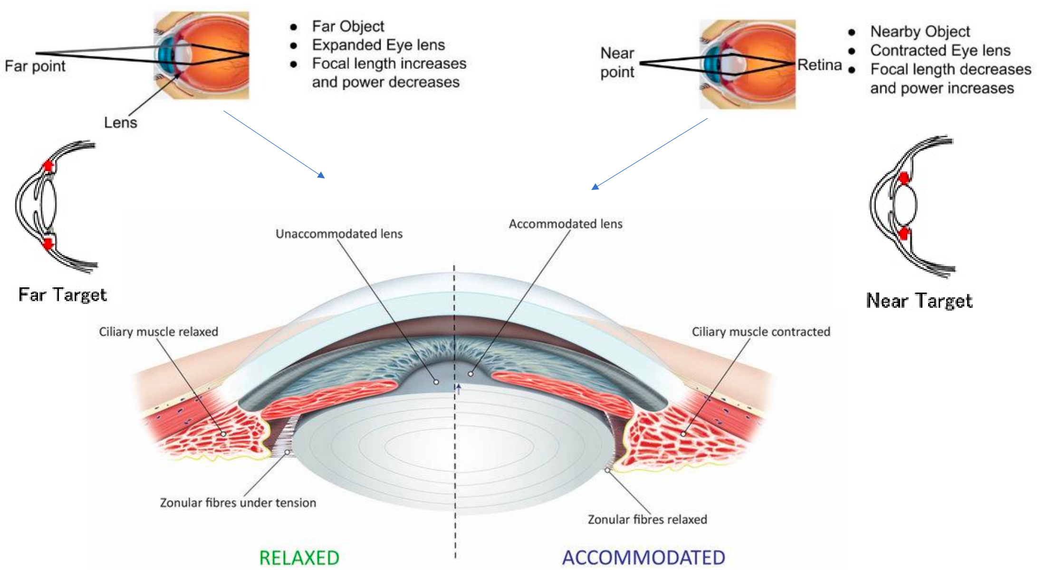
MODULE 2: Resolution of the Eye (视力与分辨率)
1. Visual Acuity (视力)
·Normal: 6/6 (meters) or 20/20. MAR (Minimum Angle of Resolution) = 1 arcminute (1/60 degree). Better than normal = e.g., 6/5.数值越大视力越好
·Snellen Chart: Visual acuity is a measure of the eye's ability to distinguish fine details and is often tested using a Snellen chart.
Symbols = 视标Optotypes. Stroke/gap width is 1/5 of letter height. Fraction = Test distance / Letter size (distance normal eye reads it).
所需距离 = 标准测试距离 × (分子 / 分母)Children can be tested with shapes/numbers before knowing alphabet.
2. Formulas (计算题必考)
Min resolvable dot pitch (mm) = Distance × tan(1/60°).
Dot pitch (mm) = 25.4 / PPI. PPI = √(H² + V²) / Diagonal(inches).
4K vs 1080p: 4K (3840×2160) has 4x pixel resolution of 1080p (1920×1080). At 2m away from 55" TV, human eye cannot distinguish 4K vs 1080p.
3. Pinhole Test (针孔测试)
Vision improves = Refractive error (屈光不正).
Vision does NOT improve = Underlying Eye disease (眼病).
- Visual acuity is the resolution分辨 capability of the eye. Your ability to see fine details is determined by the spacing of the photoreceptor cells感光细胞. The Snellen eye chart视力表 has a large E at the top with decreasing letter size from top to bottom. Eye charts can also use other optotypes视表, such as shapes or numbers. Measurement of visual acuity is based on the minimum angle of resolution最小分辨角. Visual acuity is written as a fraction where the numerator is the test distance and the denominator is the letter size字母大小.

MODULE 3: Depth Perception (深度知觉)
1. Binocular Vision & Stereopsis
·Binocular disparity: Right eye sees left image, left eye sees right image (crossed).
·Stereopsis立体视觉 is most important for close-up tasks (e.g., pouring coffee).
·Depth without stereopsis: YES (Monocular cues exist). Distant objects = less detailed & more blue.
·Looming逼近效应: Bus approaching → stimulates larger area of retina.
2. 3D Technology & Eye Turns
·Active shutter: Uses persistence of vision.
·Linear polarisation: Must keep head level (otherwise fails).
·Strabismus: Exotropia (outward), Esotropia (inward). Brain suppresses one image → Amblyopia (弱视).
·Amblyopia treatment: Patch the good eye. Amblyopia does NOT affect colour vision.
- In 3D movies, each eye sees a different image to create the illusion of depth.
- The latest active shutter 3D movie technology makes use of a phenomenon called persistence of vision.
- The slight offset in the image seen by each eye is called binocular disparity/retinal disparity双眼视差. The brain combines the visual information from the two eyes to produce stereopsis立体视觉, the perception of depth. Similarly, 3D movies work by presenting slightly different images to each eye. This is achieved using coloured or polarised 彩色或偏振眼镜filterss. Failure of the two eyes to maintain proper alignment is called strabismus斜视. A person with this condition may have diplopia复视 or they may see only one image due to suppression抑制 of the visual input to the brain from the turned eye. One treatment for this condition is vision therapy, which uses eye exercises to improve the function of the extraocular muscles眼外肌.

MODULE 4: Colour Vision (色觉)
1. Colour Theory & Physiology (色彩理论与生理)
·Additive Colour Mixing (加色法): Red + Green + Blue light = White. (This is different from subtractive mixing with paints).
·Photoreceptors: Colour vision is mediated by Cones (视锥细胞). They are densely packed in the Fovea (中心凹) and require bright light to function.
·Trichromatic Theory (三色理论): Normal human colour vision requires three types of cones: S-cones (Blue), M-cones (Green), and L-cones (Red).
2. Abnormal Colour Vision (CVD - 色觉异常)
·Prevalence & Genetics: More common in males (approx. 8%) than females (approx. 0.5%) because the most common types are X-linked recessive (伴X染色体隐性遗传).
·People with abnormal colour vision DO NOT see the world in shades of grey (except for extremely rare Achromatopsia 全色盲). They just confuse specific colours. Achromatopsia — associated with poor visual acuity.
colour vision deficiency can also be acquired (e.g., disease, injury, medication/toxins), not only congenital（天生的）.
Types of Red-Green Deficiency (Most common):
Protanopia (红色盲): Missing L-cones. Red colors appear darker/muted (e.g., pink looks greyish, red looks brown).
Deuteranopia (绿色盲): Missing M-cones. Red and green look very similar (often appearing dull yellowish-brown). most common colour vision deficiency.
Tritanopia (蓝色盲): Missing S-cones (rare).
- Daily Life Difficulties
Indicator Lights: Cannot distinguish red (error/charging) and green (safe/fully charged) LED lights.
Navigation: Difficulty reading colour-coded maps (e.g., MTR maps) or traffic lights.
Shopping: Hard to tell if fruit is ripe (red vs green apples) or distinguish similar packaging.
Safety: Cannot easily spot green emergency release boxes against a grey wall.
- Assessment
Ishihara Plates (石原氏色盲检测图): The standard test using coloured dots to detect red-green colour blindness.
- Lines on the chromaticity diagram along which colours cannot be discriminated by a dichromat are called colour confusion lines.
- Inherited (congenital) 先天性colour vision deficiencies are usually similar in both eyes. In contrast, acquired colour vision deficiency can affect the two eyes differently, so colours may appear different between the two eyes.
Congenital colour vision deficiency is usually present from birth and remains stable throughout life. Acquired colour vision deficiency, however, may change over time depending on the underlying cause.
- The colours that you perceive when looking around the world depend on the wavelengths波长 of visible light reflected from different objects. Humans with normal colour vision are trichromats三色觉者 meaning that they have three types of cones视锥细胞 that are sensitive to different wavelengths of light. The whole spectrum of colours can be perceived by the brain by additively mixing the varying levels (or amounts/intensities) of response from the S, M, and L cones.People with only two types of cone photoreceptors are dichromats二色觉者 and have trouble distinguishing colours that fall along colour confusion lines of the CIE Chromaticity Diagram. Colour vision can be tested using Ishihara plates (or pseudoisochromatic plates) in which numbers or shapes visible to individuals with normal colour vision will appear the same colour as the background to individuals with colour vision deficiency.

MODULE 5: Common Eye Conditions (眼病)
1. Refractive Errors & Lens
·Myopia近视: Eye grows too long. Hyperopia: Focus behind retina.
·Astigmatism远视: Multiple focal points. Presbyopia: Loss of lens elasticity.
·Anisometropia屈光参差: Large difference in refractive error between eyes.
·Presbyopia老花眼 results from ageing changes in lens
·LASIK屈光手术: Removes tissue from Cornea (角膜).
·Cataract白内障: Cloudy lens. Nuclear sclerosis = yellowing center. Risks = Diabetes, Smoking, UV. Treatment = Surgery.
·Contact lenses: Improper use can cause vision-threatening infection.
2. Glaucoma & AMD
Glaucoma青光眼: Optic cupping. Treatment = Drops that decrease production or increase outflow. NOT ALWAYS high pressure (Normal-tension glaucoma exists).
AMD年龄相关性黄斑变性: Dry type most common (Drusen deposits). Affects central vision. Advanced = Low vision devices.The yellow deposits that form at the macula in patients with AMD are called drusen
3. Diabetic Retinopathy
a complication of diabetes characterised by damage to the blood vessels of the retina. Proliferative type causes neovascularisation; complications include vitreous haemorrhage, retinal detachment, and glaucoma. Macular oedema is swelling in the central retina due to fluid leakage.
糖尿病视网膜病变是糖尿病并发症，特征是视网膜血管受损；增殖型出现新生血管，并发症包括玻璃体出血、视网膜脱离、青光眼；黄斑水肿是中央视网膜液体渗漏导致肿胀。
Proliferative增殖型: Causes neovascularisation (新生血管). Complications = Vitreous haemorrhage, Retinal detachment, Glaucoma.
Macular oedema: Swelling in central retina due to fluid leakage.

MODULE 6: How to Protect Your Eyes (护眼)
- UV: UVA is most damaging to lens. Snow-blindness affects the Cornea (角膜). Pterygium (翼状胬肉) caused by UV.Non-cancerous wing-shaped growths caused by UV exposure that extend from the conjunctiva over the cornea are called Pterygium
- Sports: Basketball causes most injuries. Best lens = Polycarbonate (抗冲击).
- Screen Use: Blink rate decreases → Dry eyes. Flashes of light is NOT a CVS symptom (indicates retinal视网膜 issue). Blue light suppresses melatonin.
- Lenses: Photochromic (变色片) for indoor/outdoor. Progressive lenses (渐进片) view screen at 15-20° downward.
- Myopia Control: Outdoor time lowers risk. Medical = Atropine, OK lenses, DIMS lenses. (Vision therapy is NOT effective).
- Wearing sunglasses that block UV-A and UV-B rays can help reduce the risk of developing cataracts. (戴防紫外线太阳镜降低白内障风险)
- The 20-20-20 rule suggests that for every 20 minutes of screen time, one should look at something 20 feet away for 20 seconds to reduce eye strain. (20-20-20 法则)
- A diet rich in antioxidants, such as vitamins C and E, may help maintain the health of the retina. (富含抗氧化剂的饮食有助于视网膜健康)
- - A diet rich in antioxidants, such as vitamins C and E, may help maintain the health of the retina.
- - Regularly using medicated eye drops is NOT a recommended preventive practice for everyone. Medicated eye drops should be used only under medical advice for specific conditions. Lubricating/artificial tears may relieve dryness but do not prevent all eye diseases.
- 富含抗氧化剂如维生素 C、E 的饮食可能有助于维持视网膜健康。药物性眼药水不应作为所有人常规预防眼病的方法，应遵医嘱针对特定疾病使用；润滑型人工泪液可缓解干眼，但不能预防所有眼病。

